**Demo 1 - Finding and Installing a NuGet Package**

# Using the Add Library Package Reference Dialog Box

This topic describes how to install a NuGet package using the **Add Library Package Reference** dialog box. To install a package, you must have a solution open in Visual Studio.

As an alternative, you can install packages using PowerShell commands. For more information, see [Finding and Installing a NuGet Package Using the Package Manager Console](http://nuget.codeplex.com/wikipage?title=Finding%20and%20Installing%20a%20Package%20Using%20the%20Package%20Manager%20Console).

**Finding a Package**

In **Solution Explorer**, right-click the project, click **Add**, and then click **Add Library Package Reference**.

[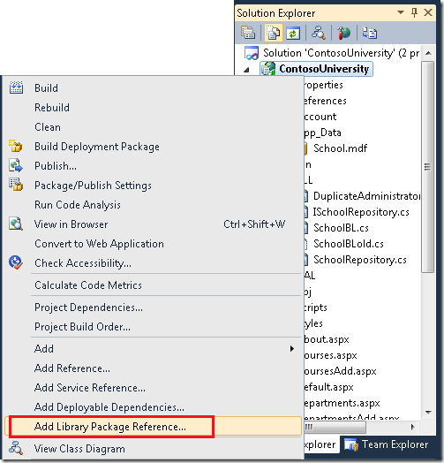](http://download.codeplex.com/Project/Download/FileDownload.aspx?ProjectName=nuget&DownloadId=189348)

Click the **Online** tab to display the list of available packages.    
  
[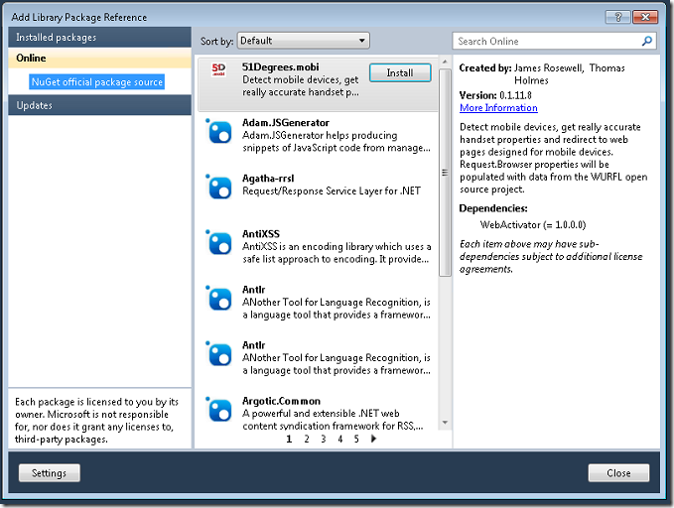](http://download.codeplex.com/Project/Download/FileDownload.aspx?ProjectName=nuget&DownloadId=187005)

Browse through the list, or search for a package using the search box at the top right of the dialog box. For example, to find the logging package named ELMAH, enter "elmah" or "logging".

Long lists are divided into pages. Use the paging links at the bottom to move from page to page.

[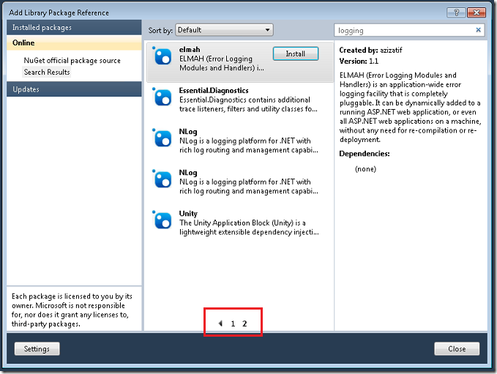](http://download.codeplex.com/Project/Download/FileDownload.aspx?ProjectName=nuget&DownloadId=187007)

When you select a package, an **Install** button appears, and a description is shown in the right-hand pane.

**Installing a Package**

To install a package, select it and then click **Install**. NuGet installs the selected package and any other packages it is dependent on. Files are copied to the solution, references might be added to the project, the project *app.config* or *web.config* file might be updated, etc.

You might be asked to accept license terms.

[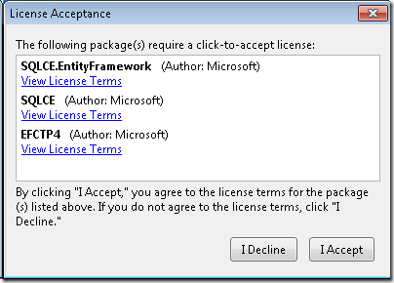](http://download.codeplex.com/Project/Download/FileDownload.aspx?ProjectName=nuget&DownloadId=189390)

When the installation completes, the **Install** button turns into a green check mark.

[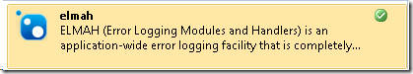](http://download.codeplex.com/Project/Download/FileDownload.aspx?ProjectName=nuget&DownloadId=189350)

In **Solution Explorer**, you can see references that Visual Studio has added for the installed library or libraries.

[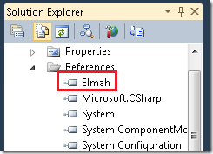](http://download.codeplex.com/Project/Download/FileDownload.aspx?ProjectName=nuget&DownloadId=187011)

If your *app.config* or *web.config* file required changes, those have been applied. The following example shows some of the changes for ELMAH.

[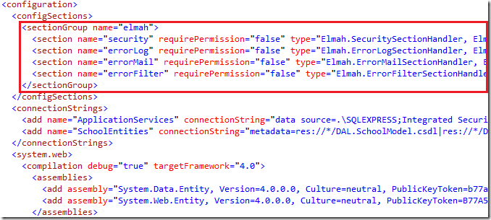](http://download.codeplex.com/Project/Download/FileDownload.aspx?ProjectName=nuget&DownloadId=187013)

A new folder named *packages* is created in your solution folder. (If your project does not have a solution folder, the *packages* folder is created in the project folder.)

[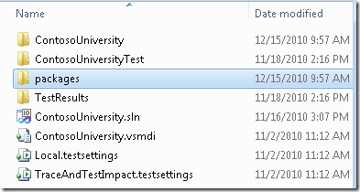](http://download.codeplex.com/Project/Download/FileDownload.aspx?ProjectName=nuget&DownloadId=187015)

The *packages* folder contains a subfolder for each installed package. This subfolder contains the files installed by the package. It also contains the package file itself (the *.nupkg* file, which is a *.zip* file that contains all of the files included in the package).

[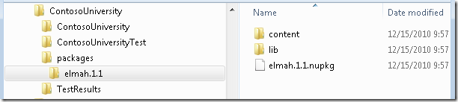](http://download.codeplex.com/Project/Download/FileDownload.aspx?ProjectName=nuget&DownloadId=187017)

Build the solution. When the build process is done, you see the referenced assembly in the *bin* folder in **Solution Explorer**.

[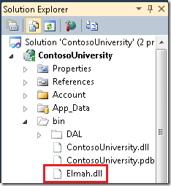](http://download.codeplex.com/Project/Download/FileDownload.aspx?ProjectName=nuget&DownloadId=187019)

You can now use the library in your project. IntelliSense works when you enter code, and library features such as the ELMAH logging information page work when you run the project.

[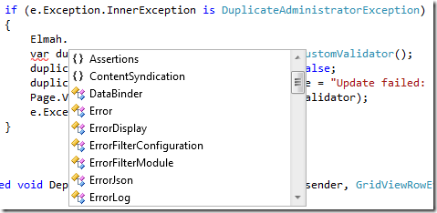](http://download.codeplex.com/Project/Download/FileDownload.aspx?ProjectName=nuget&DownloadId=187021)

[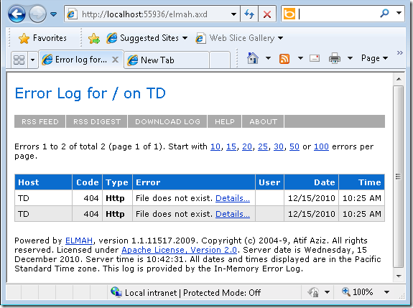](http://download.codeplex.com/Project/Download/FileDownload.aspx?ProjectName=nuget&DownloadId=187023)

# Using the Package Manager Console

Using PowerShell commands is required if you want to install a package without having a solution open. It's also required in some cases for packages that create commands that you can access only by using PowerShell.

**Finding a Package**

From the **Tools** menu, select **Library Package Manager** and then click **Package Manager Console**.

The **Package Manager Console** window is displayed.

[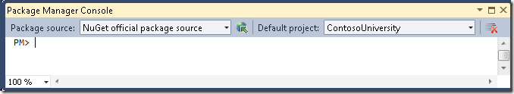](http://download.codeplex.com/Project/Download/FileDownload.aspx?ProjectName=nuget&DownloadId=189365)

The two drop-down lists, Package source and Default Project, set default values that let you omit parameters from the commands you enter in the window:

* In the **Package source** list, select the default source (NuGet package feed) that you want your commands to use.  Typically you will leave this as its default value of **NuGet official package source**. For more information about alternative feeds, see [Hosting Your Own NuGet Feeds](http://nuget.codeplex.com/wikipage?title=Hosting%20Your%20Own%20Local%20and%20Remote%20NuPack%20Feeds).
* In the **Default project** list, select the default project that you want your commands to work with. (The default value will be the first project in the solution, not necessarily the one you have selected in **Solution Explorer** when you open the window.)

When you enter commands, you can override these defaults.

In the **Package Manager Console** window, enter get-package –remote at the prompt to see a list of all packages that are available in the selected package source.     
  
[[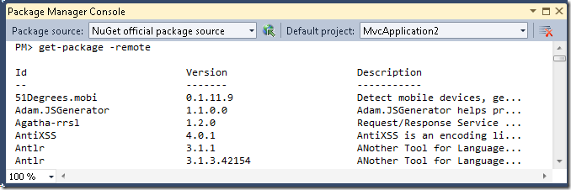](http://www.codeplex.com/Project/Download/FileDownload.aspx?ProjectName=nuget&DownloadId=168858)](http://www.codeplex.com/Project/Download/FileDownload.aspx?ProjectName=nuget&DownloadId=168858)You can specify a filter for the get-package command. For example, to find the logging package ELMAH, enter get-package –remote –filter elmah (the name of the package) or get-package –Filter logging (a keyword in the package description).

[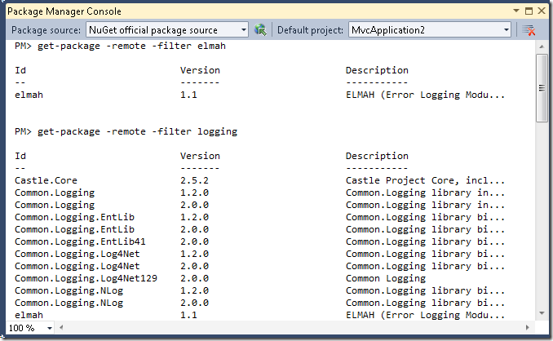](http://download.codeplex.com/Project/Download/FileDownload.aspx?ProjectName=nuget&DownloadId=189643)

For more options that you can specify with the get-package command, enter get-help get-package, or see [Package Manager Console Commands](http://nuget.codeplex.com/documentation?title=Package%20Manager%20Console%20Command%20Reference).

**Installing a Package**

After you have found a package that you want to install, use the install-package command with the name of the package. For example, enter the command install-package elmah as shown in the following example:

[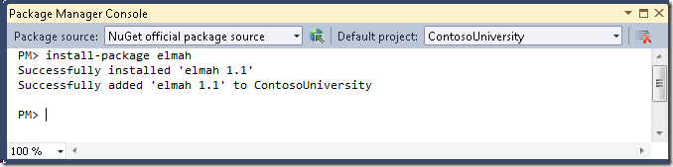](http://download.codeplex.com/Project/Download/FileDownload.aspx?ProjectName=nuget&DownloadId=189370)

For more options that you can specify with the install-package command, enter get-help install-package or see [Package Manager Console Commands](http://nuget.codeplex.com/documentation?title=Package%20Manager%20Console%20Command%20Reference).

NuGet retrieves the package from the specified package source and installs it in the project that is selected in the **Default project** drop-down list (unless you specify a different project in the command). Files are copied to the solution, references might be added to the project, the project *app.config* or *web.config* file might be updated, etc. If the package you are installing is dependent on other packages, NuGet installs them also if they are not already installed.

If the package requires license acceptance, you will not be prompted in a dialog box. Instead, a message states that your use of the library constitutes license acceptance.

[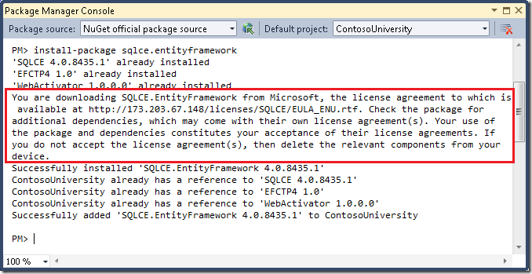](http://download.codeplex.com/Project/Download/FileDownload.aspx?ProjectName=nuget&DownloadId=189392)